 | Abdi İpekçi Caddesi Kaşıkçıoğlu Apt. No:42 D:2 34365 Nişantaşı İstanbul  www.artxist.com  info@artxist.com  T. +90 212 291 77 84 F. +90 212 343 69 35 | PRESS RELEASE

“Everyone Carries A Shadow”

x-ist is hosting the photographer Lale Tara’s 2nd solo exhibition
between September 10th and October 19th.

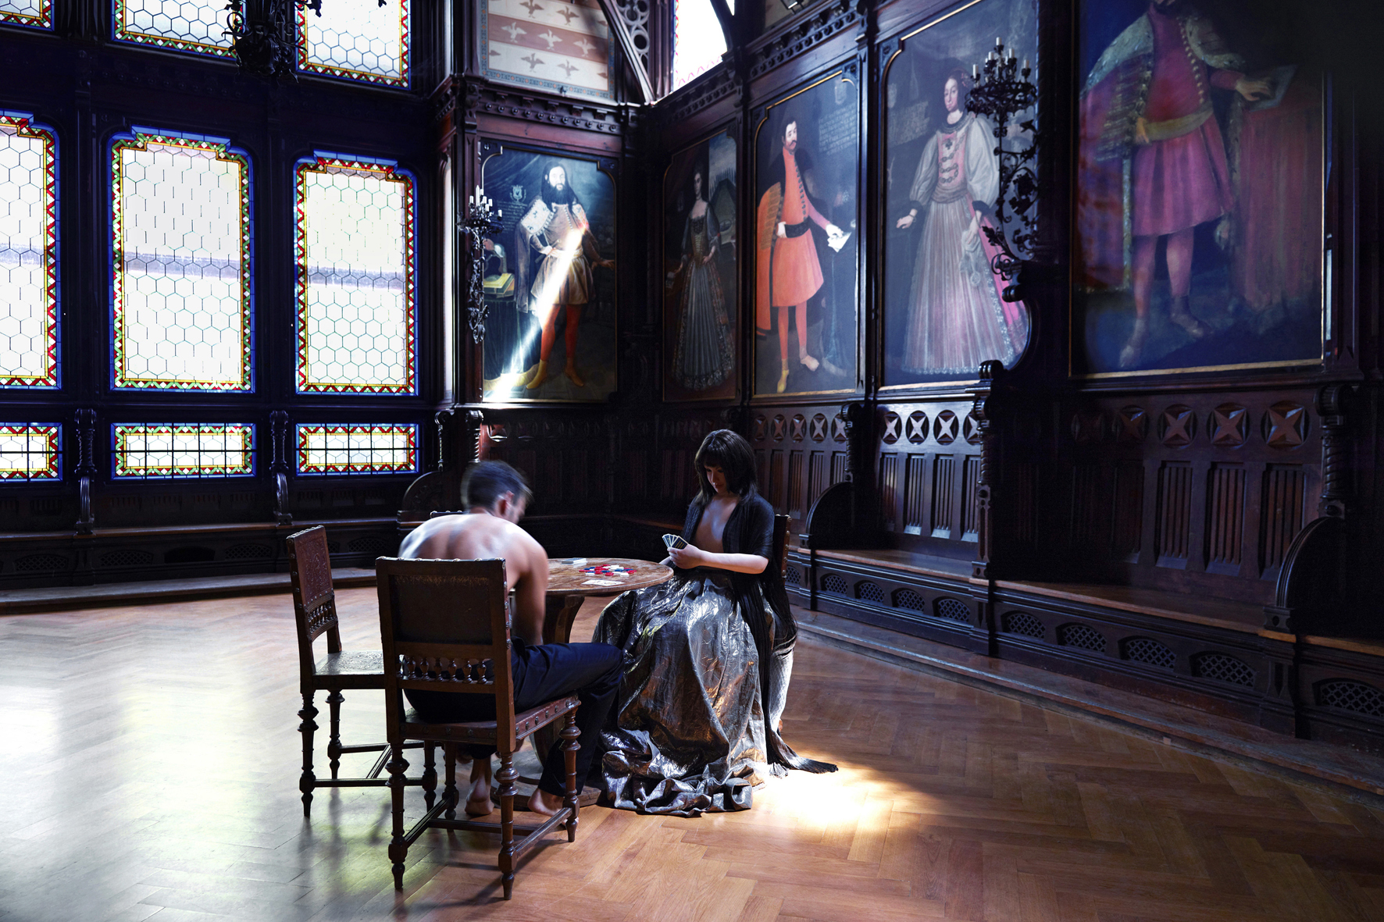
Lale Tara, “card players”, Photography, 80 x 120 cm, 3 ed. – 120 x 180 cm, 3 ed., 2012

After her solo exhibitions titled "Alive" (Bilsar, 2006) and "Hello Earth Goodbye" (Bilsar, 2007), the photographer Lale Tara met the art-lovers at x-ist with her exhibition titled "Doppelgänger (RUI)" in 2009. The artist, who has been exhibited in different cities all around the world, such as Strasbourg, Hong Kong, Basel, London, Bombay, Taipei, Singapore, Dubai, and Tokyo, presented her recent series "Innocent Surrogates" in the photography section of Istanbul Modern Museum in 2011.
Lale Tara opens her new solo show "Everyone Carries a Shadow" at x-ist. The shooting of the twelve photographs that made up the series took place in different, abandoned spaces in Hungary. The scenes, written and directed by Tara, are constructed by human sized plastic surrogates. Through this replica, which appears as a manifest of her secondary existence, Lale Tara touches upon the interaction between the different artistic media and deliberately distorts the indexicality of photography.

The photographs of Lale Tara, which discuss the wishes and fears that women repress due to the societal pressures, referencing various literary works, invite the audience for an introspective look, also referring to C. G. Jung's Doctrine of "the shadow of human" which suggests that the repressed does not disappear; but stays hidden in a part of the psyche called "the shadow". Via displaying everything regarding women that has been denied so far, these rebellious figures we see in the photographs - different representations of the "shadow" - challenge the strict constructions of femininity.

Artist Biography

Lale Tara
Istanbul

Lale Tara is a self-taught photographer. While photographing her visual diary “sevenmonthssevendays” published by the Robinson Crusoe Publishing House in 2005, she took several photography classes at The New School University (New York) and OCTET: School of Visual Arts (New York). Tara’s solo shows are: “Live” (Bilsar, 2006), “Hello Earth Goodbye” (Bilsar, 2007), “doppelgänger (RUI)” (x-ist, 2009), “Innocent Surrogates” (Istanbul Modern, 2011) and “Everyone Carries A Shadow” (x-ist, 2013). The artist participated in Contemporary Istanbul’09, 10, 12 & 13, Start-2009 (14th European Contemporary Art Fair, Strasbourg, France), ART HK’10 & 11 (Hong Kong International Art Fair), VIP Art Fair 2012, Unseem Amsterdam 2012, SCOPE Basel 2011 and 2012 fairs. In between the international group shows Lale Tara took place in “A Subjective Panorama on Turkish Contemporary Photography” (Maison des Métallos, Paris, 2009), “Neither Here nor There: Reflections on Cultural Hybridity and the Third Space” organized by the art initiative JAMM (Art & Beyond, London, 2010), “Tradition of the New” (Sakshi Gallery, Mumbai, India, 2010), “Between History and Tale: Contemporary Photography” (Sakshi Gallery, Taipei, Taiwan, 2010), ”Idols and Icons” (Yavuz Fine Art, Singapore, 2011), “Samawi Collection II Exhibition” (Ayyam Gallery, Dubai, 2012), “After Yesterday” (Istanbul Modern, 2012) and ”The Fairest One of All” (Yamamoto Gendai Gallery, Tokyo, 2012). Lale Tara is featured in the book “Unleashed: Contemporary Art from Turkey” first published in 2010.

